

**Software Engineering Department**

**ORT Braude College**

**Capstone Project Phase A – 61998**

**De novo study of planet movement based on sky images and Newton’s model**

**Supervisor:** Dr. Zeev Frenkel

Ibraheem Sabaane - ibraheem.sabaane@e.braude.ac.il

Mario Rohana - Mario.Rohana@e.braude.ac.il

23-2-R-1

Content

**1. Introduction 3**

**2. Background and Related Work 4**

2.1 Basic physical model 4

2.1.1 Gravity 4

2.1.2 Cinematics 5

2.1.3 Coordinate systems and coordinate transformation 5

2.1.4 The main objects in the model: Earth, Moon, Sun, Planets, 13

Stars (movement) 13

2.2. View of sky image from the Earth 17

2.2.1 Visible vs real 17

2.2.2 Typical trajectories of the main objects 19

2.3 Automatic searching and tracking of the sky objects 20

**3. Materials and Methods 23**

3.1 Datasets 23

3.2 Hardware and Software 24

**4. Goals and expected achievements 24**

4.1 Goals 24

4.2 Expected achievements from this research 24

**5. Process 25**

5.1 Preliminary Research 25

5.2 Data Collection 26

5.3 Algorithm Development and Refinement 26

5.4 Collaboration and Teamwork 26

5.5 Future Plans 26

5.6 Pseudocode 27

**6. Research plan 28**

6.1 Astrophysical Data Analysis and Interpretation 28

6.2 Validation Plan 29

6.3 Diagrams 30

6.3.1 Use Case 30

6.3.2 Activity Diagram 31

6.3.3 Class Diagram 32

6.3.4 Draft of Gui 33

6.4 Evaluation/Verification Plan 36

**References 38**

**Abstract**

In this project we are merging classical physics and computational techniques to decode the complex observable choreography of celestial bodies. Our model is based only on principles like gravity and kinematics to intricate discussions on celestial bodies and their movements. Our unique perspective investigates celestial phenomena from Earth's standpoint. Exploring the differences between actual and apparent dimensions of celestial bodies we will improve the model (the influence of Earth's atmosphere on sky images is ignored in our project). We also develop state-of-the-art techniques for automatic detection and tracking of sky objects on sky images. The book features a detailed walkthrough of our de novo study, bridging sky images with planet movement predictions based on Newton's mechanics and gravity model. Complete with practical case studies and vivid illustrations, Our project offers a compelling journey into the computational exploration of celestial movements, designed for stargazers, astronomers, and scientists alike.

## **1. Introduction**

The fascination with celestial objects and their movements has been a cornerstone of human curiosity for centuries. Despite significant advancements in this field backed by cutting-edge technology, skepticism and conspiracy theories about the basic model of the Solar system continue to pervade. In response to this challenge, our project aims to dispel doubts and illuminate understanding by developing an open-source software that draws a tangible link between sky views and the predicted movement of celestial bodies, based on the principles of Newton's classical mechanics and gravity model.

We delve into a de novo study, starting from raw sky images as our primary data. Our process involves detecting and locating objects such as the Sun, the Moon, the most visible stars, and some planets in these images. We then simulate their movements based on Newton's model and compare these simulations with the observed data to ascertain the best model parameter values, thereby minimizing discrepancies between the observed data and model predictions.

Our project offers profound benefits to a broad spectrum of individuals. It serves as a remarkable educational tool for teachers and students alike, making the complex concepts of celestial movements tangible and comprehensible. Amateur astronomers can employ this tool to gain deeper insights into the wonders of our sky. Beyond this, professional astronomers and researchers could potentially leverage our software as a robust visualization and simulation tool in their work, furthering their understanding and exploration of the universe. In essence, our project acts as a bridge, connecting curiosity to understanding, and skepticism to enlightenment.

This paper is organized into seven key sections, each contributing to the understanding, execution, and presentation of our project. These sections delve into scientific backgrounds, detailed methodologies, pseudocode representations, goals and expected achievements, research planning, preliminary software engineering documentation, and the appropriate referencing of our resources. In doing so, we aim to provide a comprehensive insight into the development, execution, and outcomes of our project.

## 

## **2. Background and Related Work**

### 2.1 Basic physical model

#### 2.1.1 Gravity

The law of universal gravitation, discovered by Sir Isaac Newton, is a fundamental principle in celestial mechanics. It states that the force of attraction between any two objects in the universe is directly proportional to their masses and inversely proportional to the square of the distance between them (Fig. 1)[11].

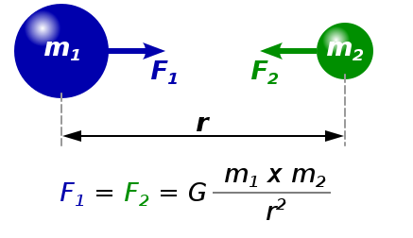

Figure 1**:** Gravity: the force of attraction between any two objects in the universe is directly proportional to their masses and inversely proportional to the square of the distance between them. Here F is the force of attraction, m1 and m2 are the masses of the objects, r is the distance between them, and G= $6.6743 × 10^{-11} m^{3} kg^{-1} s^{-2}$ is the gravitational constant.

#### 

#### 2.1.2 Cinematics

The term "cinematics" refers to the study and analysis of the motion of celestial objects, specifically their cinematics, which involves describing and understanding their positions **x**, velocities **v**, and accelerations **a**. Bold font indicates that the variable is a vector: **x**=(x1,x2,x3), **v**=(v1,v2,v3) and **a**=(a1,a2,a3). Remind that the velocity characterizes the changing of the coordinate on time **v**=**x**’=d**x**/dt. Acceleration characterizes the changing of the velocity on time **a**=**v’**=**x**’’=d2**x**/dt2. In order to simulate the movements of celestial objects, we will use classical mechanics principles, including the equations of motion **F** = m**a**, which relates the force acting on an object to its mass and acceleration. We will also use the principle of superposition, which states that the total force on an object is the vector sum of the individual forces acting on it. This is expressed mathematically as **F** = **F**1 + **F**2 + ... + **F**n.

For the system of n objects we have the following system of the differential equations:

(1)-(n) mi**x**i’’(t)= G mi ∑j≠i (**x**j(t)-**x**i(t)) mj / |**x**j(t)-**x**i(t)|3

With the following 2n initial conditions:

(1)-(n) **x**i(0)=**x**i(0)

(n+1)-(2n) **x**i‘(0)=**v**i(0)

This model have 3n parameters: masses of objects mi, initial positions **x**i(0) and initial velocities **v**i(0). In total we have 3n scalar equations with 9n scalar parameters.

Mass- distance relation:

Central acceleration a=v2/r=r w2.

Period T=2π/w.

Based on gravity, a=F/m=GM/r2.

Hence, GM/r2 =r (2π/T)2 . This means that M/r3= (2π/T)2 /G (see also 3th Kepler's law, 2.2.4.2).

#### 2.1.3 Coordinate systems and coordinate transformation

Astronomy, as a science, has always relied upon accurate measurements and observations of celestial objects. To achieve this, various coordinate systems have been developed to represent positions of these objects in the sky. Coordinate transformation is the process of converting coordinates from one system to another, which helps researchers and observers to understand and analyze celestial objects more effectively.

2.1.3.1 Different Coordinate Systems in Astronomy

There are three main coordinate systems used in astronomy: (i) equatorial, (ii) ecliptic, and (iii) horizontal. The equatorial coordinate system is based on the celestial equator, which is the projection of Earth's equator onto the celestial sphere. In this system, the position of an object is expressed in terms of right ascension and declination (Fig. 2). The ecliptic coordinate system is centered on the ecliptic plane, which is the path that the Sun appears to follow across the sky. In this system, celestial objects are measured using ecliptic longitude and latitude (Fig. 3). Finally, the horizontal coordinate system is based on an observer's location on Earth, and it measures the position of objects using altitude and azimuth (Fig. 4).

* **Equatorial coordinate system:** The equatorial coordinate system is a celestial coordinate system commonly used in astronomy to describe the positions of objects in the sky. It is based on the concept of celestial spheres, imagining the Earth at the center and an imaginary sphere surrounding it called the celestial sphere.In the equatorial coordinate system, positions of celestial objects are specified using two coordinates: right ascension (RA) and declination (Dec). These coordinates are analogous to longitude and latitude on Earth, respectively.
* Right Ascension (RA): It is measured eastward along the celestial equator starting from a reference point called the vernal equinox. RA is typically measured in hours, minutes, and seconds, with 24 hours completing a full circle (360 degrees). The vernal equinox (0 hours RA) is defined as the point where the Sun crosses the celestial equator from south to north during the March equinox.
* Declination (Dec): It is measured in degrees north or south of the celestial equator. Positive values indicate objects located in the northern celestial hemisphere, while negative values represent objects in the southern celestial hemisphere. The celestial equator itself has a declination of 0 degrees.

Together, the right ascension and declination provide a unique set of coordinates for any given point in the sky, allowing astronomers to precisely locate celestial objects[15].

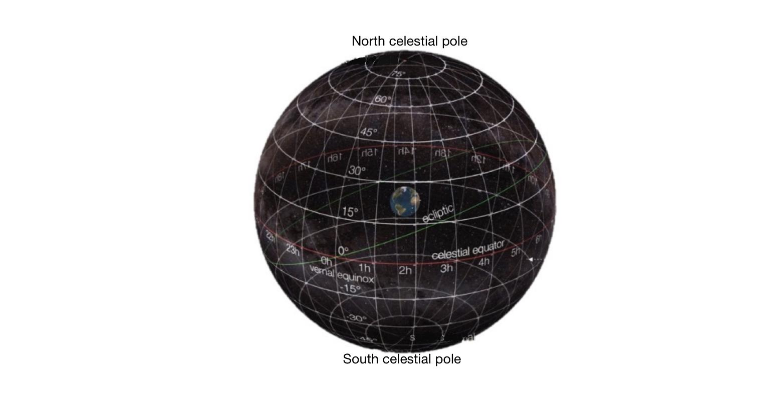

Figure 2: equatorial coordinate system

* **Ecliptic coordinate system:** The ecliptic coordinate system is another celestial coordinate system widely used in astronomy, particularly for studying the motion and positions of objects within the solar system. It is based on the plane of Earth's orbit around the Sun, known as the ecliptic.

In the ecliptic coordinate system, two coordinates are used to locate objects: ecliptic longitude and ecliptic latitude. Ecliptic longitude, also called celestial longitude, measures the angular distance along the ecliptic in the eastward direction from a reference point (often the vernal equinox). Ecliptic latitude measures the angular distance perpendicular to the ecliptic plane, similar to celestial latitude.

The system's origin can be the center of either the Sun or Earth, its primary direction is towards the vernal (March) equinox[18].

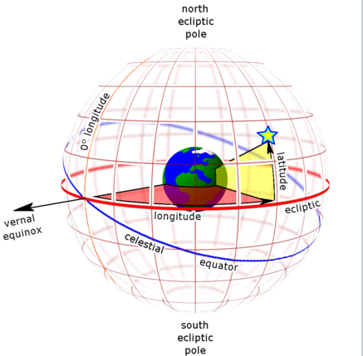

Figure 3: ecliptic coordinate system

* **Horizontal coordinate system:** The horizontal coordinate system is a celestial coordinate system that uses the observer’s local horizon as the fundamental plane to define two angles: altitude and azimuth[16].

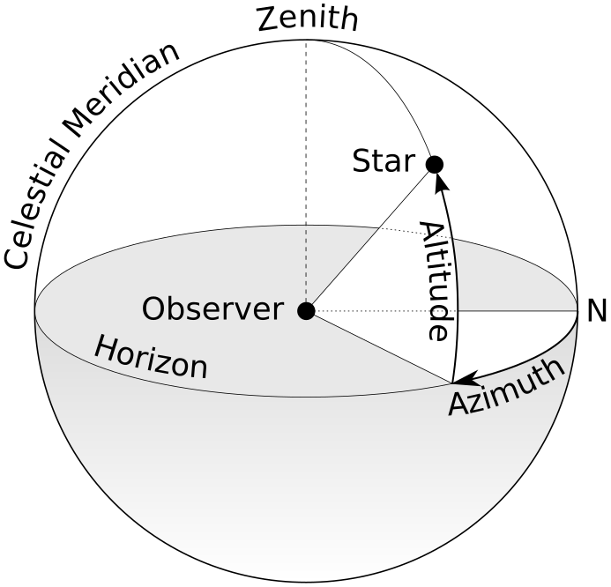

Figure 4: horizontal coordinate system.

* Altitude: is the angle the object makes with the horizon. For example objects that seems to touch the horizon have an altitude of 0 degrees.

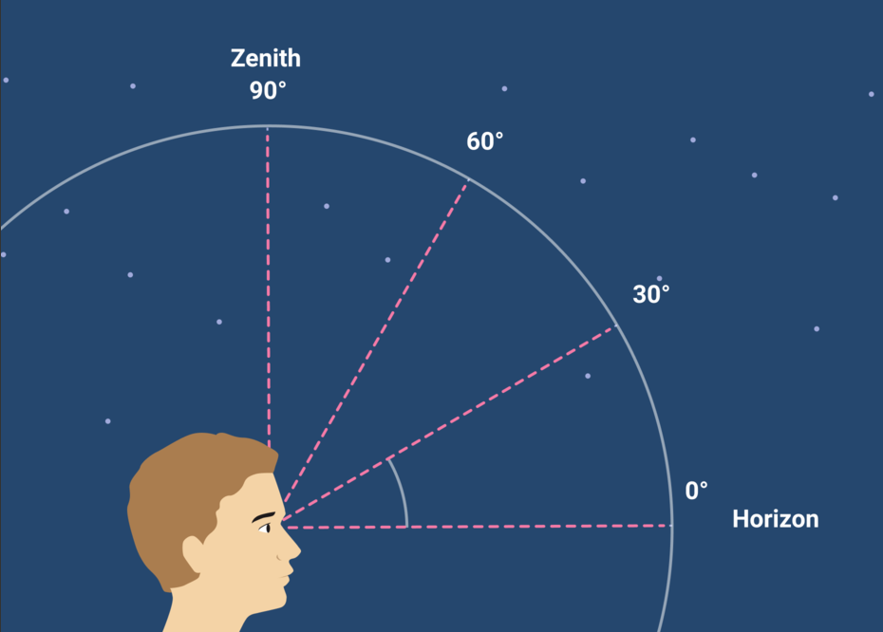

figure 5: The altitude is the angle an object makes with the horizon.

* Azimuth: the object’s cardinal, such as north, east, south, or west. It is specified as the horizontal angle the object makes with a reference direction such as true north.

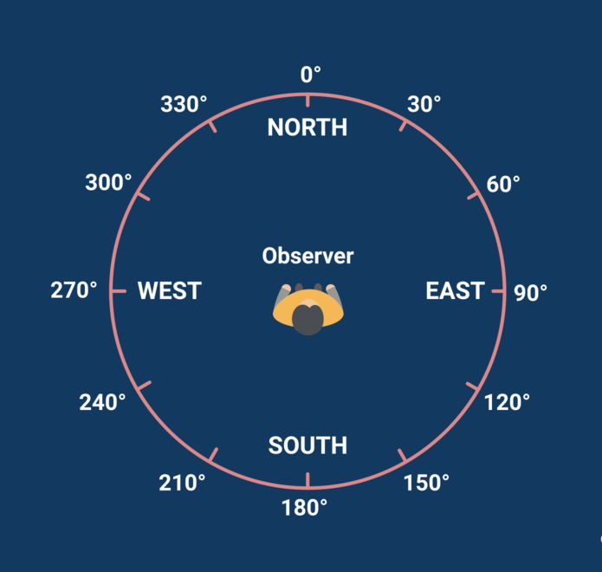

Figure 6: The azimuth refers to the object’s cardinal direction.

2.1.3.2 Euler angles

Euler angles are a set of three angles that define the orientation of a rigid body in three-dimensional space with respect to a fixed coordinate system. The three angles are typically denoted as α, β, and γ, and represent rotations around the three coordinate axes. Euler angles can be used to transform between different coordinate systems. A common convention for Euler angles is the ZYX convention, where a rotation about the z-axis is followed by a rotation about the y-axis, and then a rotation about the x-axis.

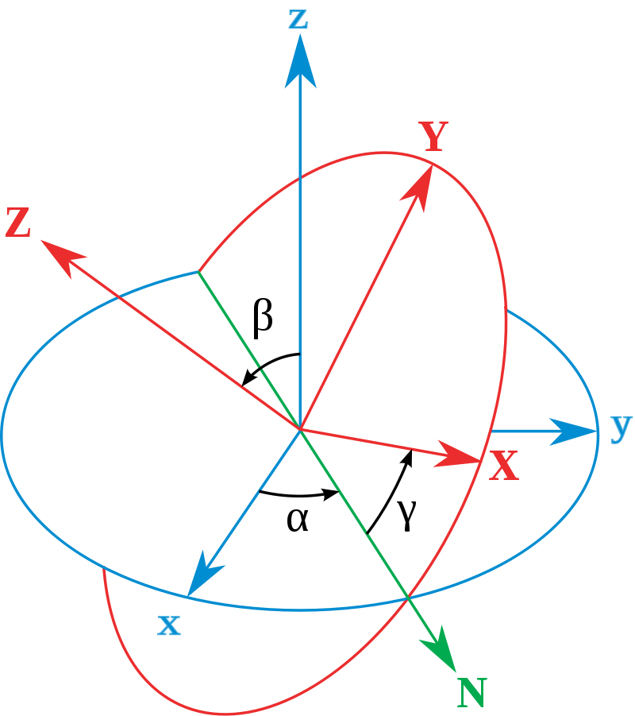

Figure 7: Euler angles. Here α is the signed angle between the x axis and the N axis (x-convention – it could also be defined between y and N, called y-convention). β is the angle between the z axis and the Z axis. γ is the signed angle between the N axis and the X axis (x-convention). — fixed coordinate system, — rotated coordinate system.

2.2.3.3 Conversion between orthogonal coordinate systems

Given the XYZ orthogonal coordinate system, find a transformation to an orthogonal system UVW (Fig. 6). Homogeneous coordinates: **x**=(x,y,z,1). In these coordinates 3D Translation is defined by matrix **T**: **x**(new)=**Tx**.

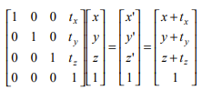

3D Rotation is defined by matrix **R** that is combination of three rotations: A counterclockwise rotation about the z-axis, A counterclockwise rotation about the x-axis and A counterclockwise rotation about the y-axis:

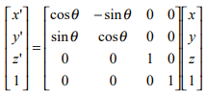,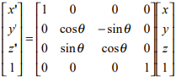

,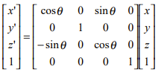

**x**(new)=**RTx**, where **R**=**R**1**R**2**R**3.

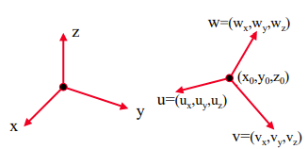

Figure 8: Conversion between orthogonal coordinate systems

Coordinate transformations are crucial for various applications in astronomy. They facilitate the conversion of telescope coordinates to sky coordinates and vice versa, allowing astronomers to point telescopes at specific targets accurately. Additionally, they enable the calculation of an object's position in the sky at any given time and place, assisting in the planning of observational studies and the interpretation of astronomical data[12].

2.1.3.4 Spherical coordinates

In mathematics, a spherical coordinate system is a coordinate system for three-dimensional space where the position of a point is specified by . This coordinate system is particularly useful when dealing with problems involving spherical symmetry or when describing directions in space. Spherical coordinates can be useful in several ways:

(i) Celestial Object Positioning: Spherical coordinates accurately determine the positions of celestial objects in the sky, aiding in precise location calculations.

(ii) Coordinate Transformation: Spherical coordinates facilitate the transformation between different celestial coordinate systems, enabling seamless integration of data from multiple sources.

(iii) Simulation and Modeling: Spherical coordinates represent the positions and orientations of celestial objects, allowing for accurate simulation of their movements based on Newton's classical mechanics and gravity model.

(iv) Sky Visualization: Spherical coordinates provide a basis for visually depicting the sky, enabling the creation of immersive and realistic representations of celestial object positions and movements[13].

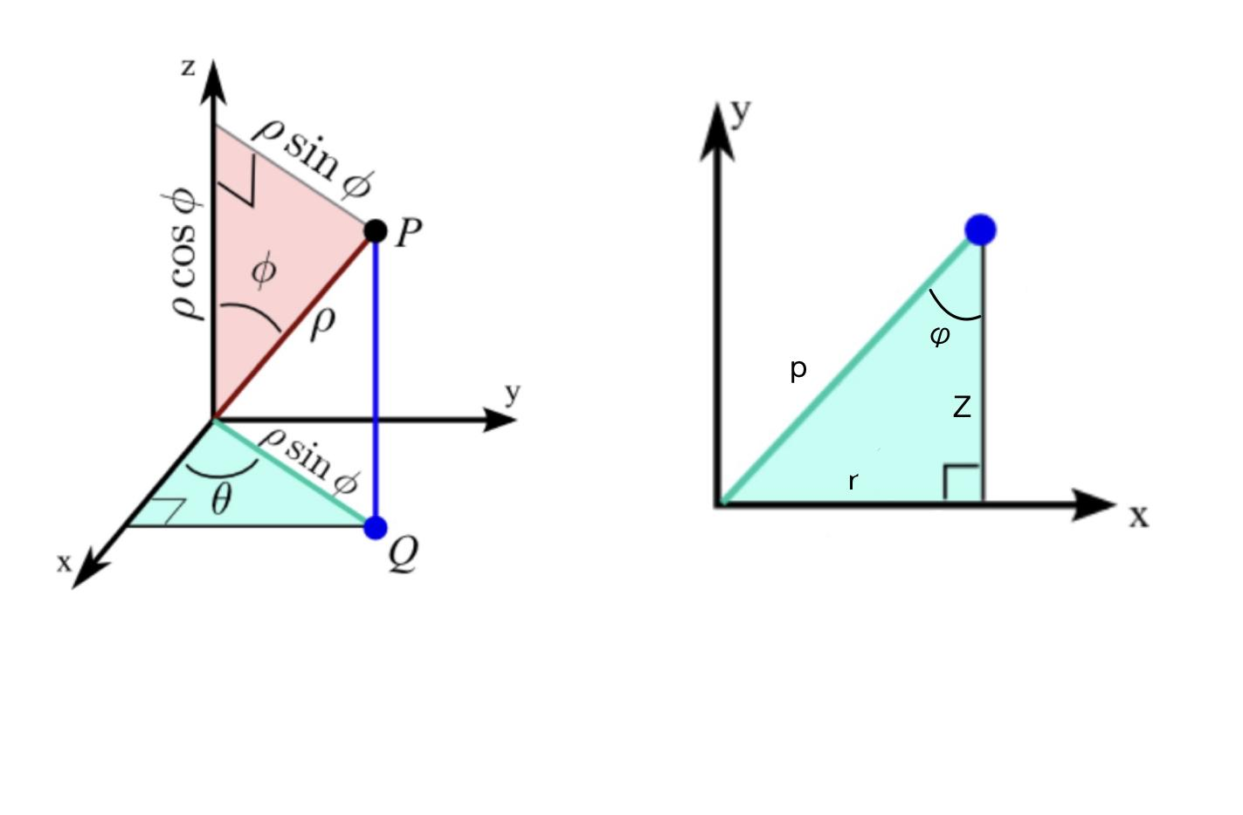

Figure 9: Spherical coordinates. {𝘱≥0 | 0≤ϴ≤2π | 0≤ϕ≤π}=>(𝘱,ϕ,ϴ)

(𝘱,ϕ,ϴ)->(r,ϴ,z)=>{ϴ=ϴ|r=psin(ϕ)|z=pcos(ϕ)}

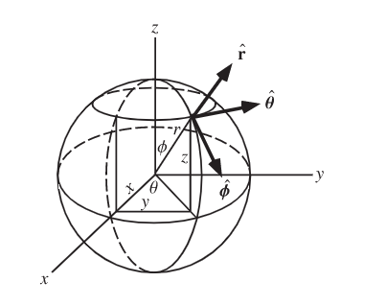

Figure 10: spherical coordinates.

#### 2.1.4 The main objects in the model: Earth, Moon, Sun, Planets,

#### Stars (movement)

The celestial objects that form the basis of our study are Earth, Moon, Sun, planets, and stars. Understanding their movement and interactions is vital to predicting their positions in the sky.

2.1.4.1 Basic Properties and Characteristics

Each celestial object has unique properties that define its appearance and motion. Earth, being our home planet, serves as the reference frame for observations. The Moon, our natural satellite, revolves around Earth in an elliptical orbit. The Sun, a G-type main-sequence star, is the center of our solar system and the primary source of light and energy for Earth. Planets are celestial bodies orbiting the Sun, and they can be classified as terrestrial (e.g., Mercury, Venus, Earth, Mars) or gas giants (e.g., Jupiter, Saturn, Uranus, Neptune). Stars are massive, luminous spheres of plasma held together by gravity, and their apparent motion in the sky is mainly due to Earth's rotation (Fig. 8).

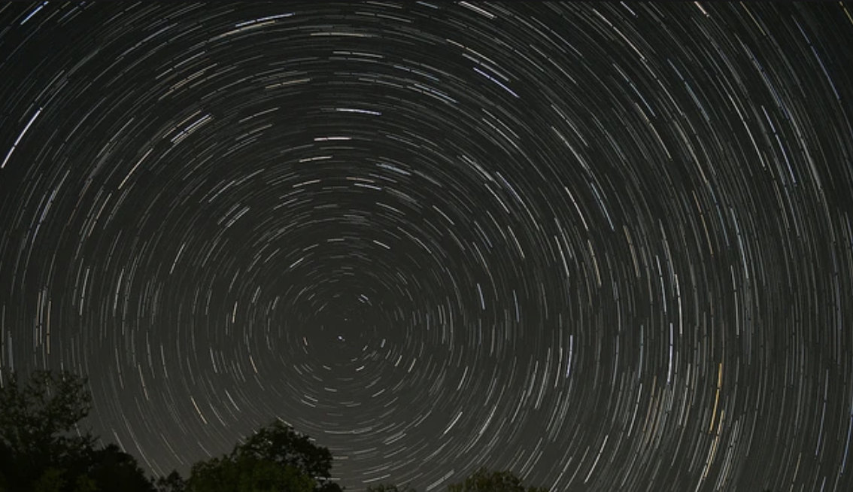

Figure 11: Visible movement of stars relative to point of view on the Earth.

2.1.4.2 Kepler's Laws of Planetary Motion

Kepler's laws describe the motion of planets around the Sun, providing a foundation for understanding celestial movement. The three laws are as follows:

1. The orbit of a planet is an ellipse with the Sun at one of the two foci (Fig. 11).

2. A line segment joining a planet and the Sun sweeps out equal areas during equal intervals of time (Fig. 12).

3. The square of a planet's orbital period is proportional to the cube of the semi-major axis of its orbit (Fig. 13).

Indeed, all these three laws can be obtained based on mathematical manipulation with the model explained in 2.2.1-2.2.3. From the perspective of an observer on Earth, the apparent motion of celestial objects in the sky is a result of both their intrinsic motion and the motion of Earth itself. Earth's rotation on its axis causes objects to rise in the east and set in the west, while its revolution around the Sun leads to the annual motion of objects along the ecliptic[1][2].

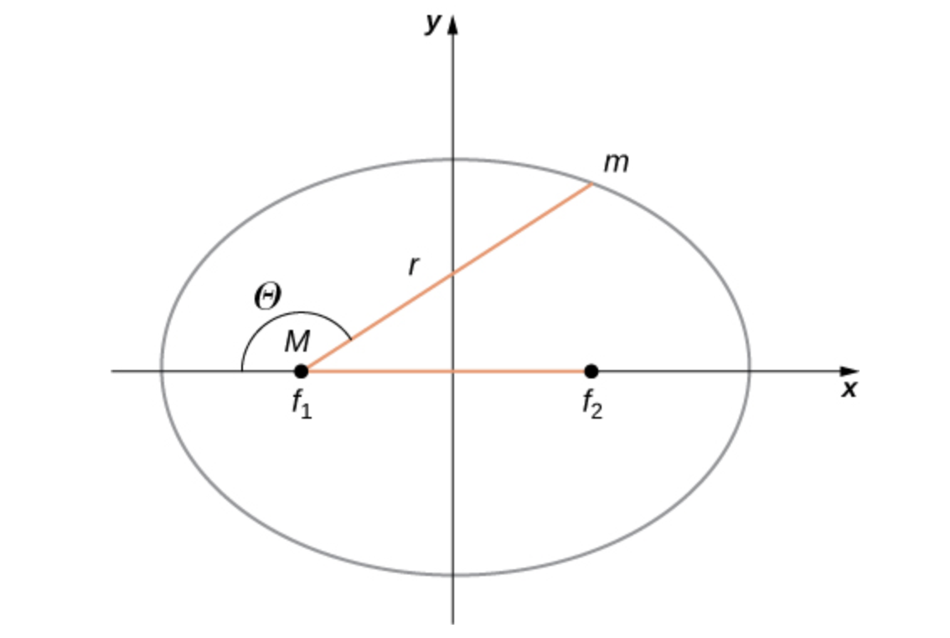

Figure 12: Kepler's Law 1: The orbit of a planet is an ellipse with the Sun at one of the two foci (f1 or f2). Such movement is characterized by the formula: *α/r*=1+*e* cos *θ*. Here r is the distance from the focus, *θ* is the angle with the axis of the ellipse, The constants α and *e* are determined by the total energy and angular momentum of the satellite at a given point. The constant *e* is called the eccentricity. In general, values of α and *e* determine which of the four conic sections represents the path of the satellite, here an ellipse.

[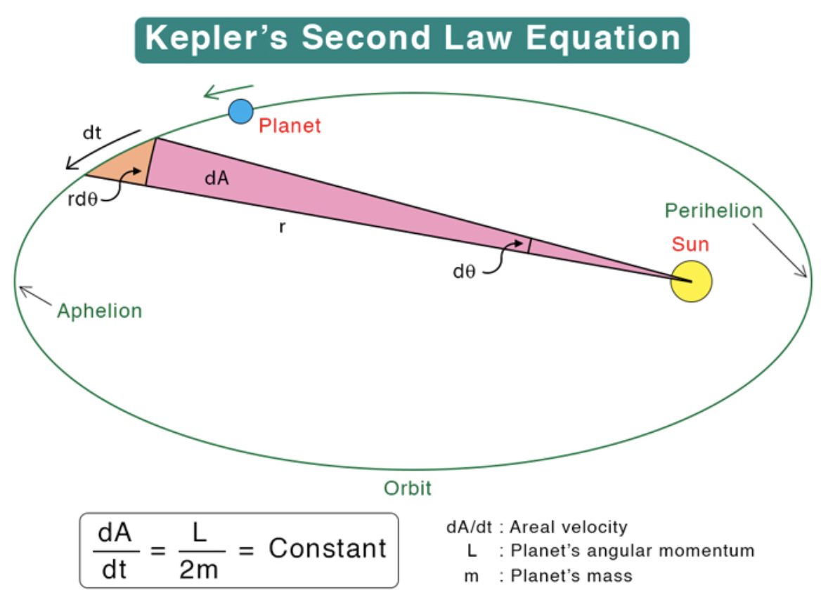](https://www.sciencefacts.net/keplers-second-law.html)

Figure 13: Kepler's Law 2: A line segment joining a planet and the Sun sweeps out equal areas during equal intervals of time

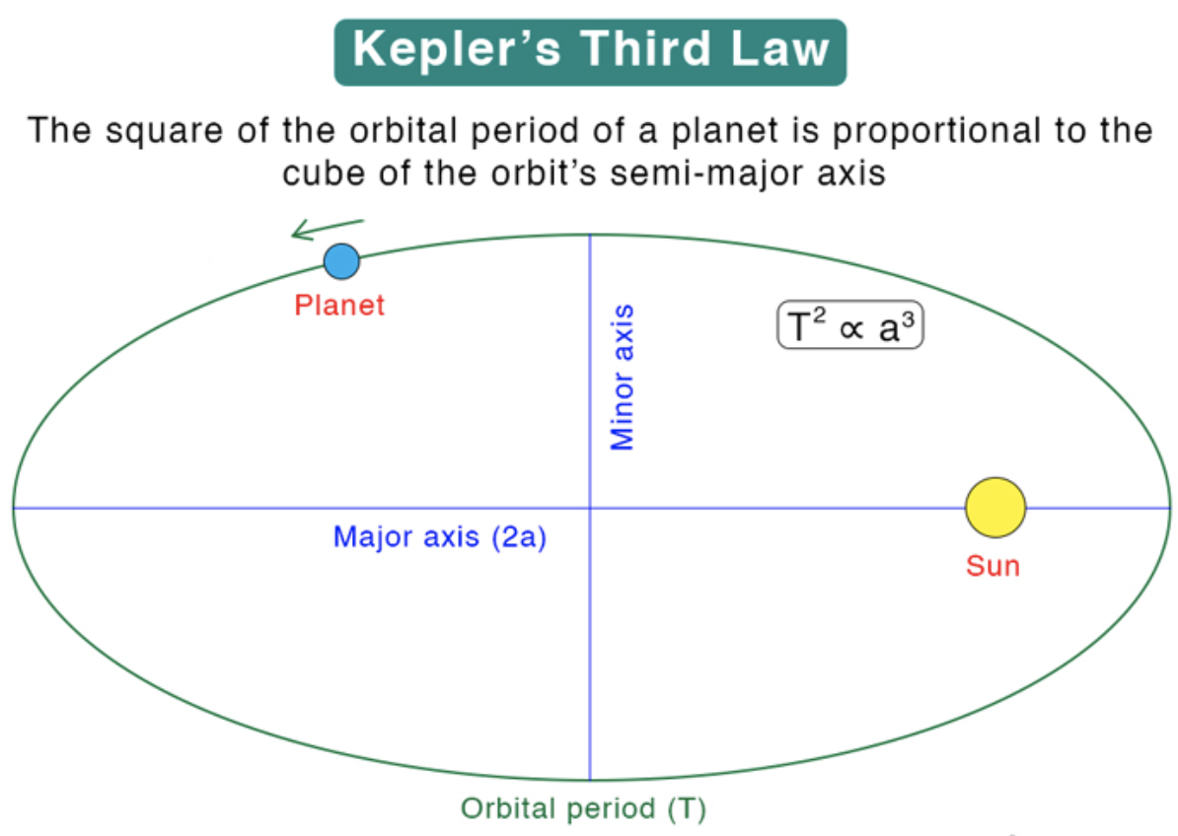

Figure 14: Kepler's Law 3: The square of the orbital period of a planet is proportional to the cube of the orbit’s semi-major axis.

### 

### 

### 2.2. View of sky image from the Earth

From Earth, we can take pictures of the night sky that give us a unique perspective of the stars, planets, and other celestial bodies. Several factors affect how these objects seem in these images. For instance, the distance between the object and Earth can affect how we see it. Additionally, the brightness of some objects naturally impacts how they seem in the images. The light produced by these objects can also be affected by Earth's atmosphere, which can change how they seem in our sky images.

#### 2.2.1 Visible vs real

2.2.1.1 Apparent vs Absolute Magnitude:

The brightness of a celestial object is measured in what's called its magnitude. When we talk about apparent magnitude, we mean how bright an object looks to us here on Earth. On the other hand, absolute magnitude is a measure of how bright an object would be if we were observing it from a standard distance of 10 parsecs away. The object's inherent brightness, along with its distance from the observer, determine the apparent magnitude of these celestial objects[3].

2.2.1.2 Earth's Atmosphere's Impact on Sky Images:

Our planet's atmosphere influences the quality of the sky images we capture. It can bend, absorb, and scatter light, resulting in less sharp, distorted images and the dimming of the objects in the sky. Astronomers often take steps to reduce these effects. They may opt to study objects from higher altitudes, use specific equipment or filters, or use sophisticated algorithms to process the images[4].

2.2.1.3 Overcoming Atmospheric Interference:

There are several techniques to offset the negative effects the Earth's atmosphere has on images of the sky. Adaptive optics systems are one such method, as they can correct for the distortion caused by atmospheric turbulence in real-time, improving the quality of images from ground-based telescopes. Another solution is to use space-based telescopes, like the Hubble Space Telescope. These devices observe from outside Earth's atmosphere, so they can capture clear images without atmospheric interference[5].

2.2.1.4 Real and visible sizes of the main objects

The real size of celestial objects often differs significantly from their visible size due to their distance from Earth.

Angular Diameter and its Relation to Real Size

Angular diameter is the apparent size of an object in the sky, expressed in degrees, arcminutes, or arcseconds (Fig. 12). It is related to the real size and distance of an object through the formula: Angular diameter = (Real size / Distance) * (180 / π). For further details see[6].

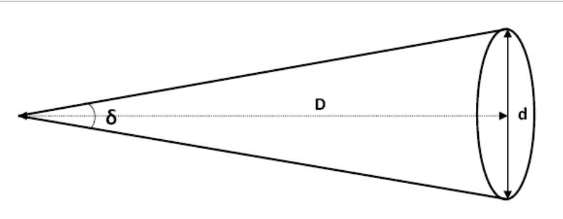

Figure 15 : The observer's location and object's apparent size in sky images. Here δ is angular diameter of a celestial object, D is actual diameter of the object and d is its distance from the observer.

2.2.1.5 Factors Affecting the Visible Size of Celestial Objects

There are several factors that change how big celestial objects look to us. These include how far away the object is from Earth, the object's actual size, and how much a telescope or other instrument enlarges the object's image.

**Comparison of Real Sizes and Apparent Sizes for Key Objects in Our Study:** For the main objects we're studying, it's helpful to compare their real sizes and how big they appear to us. A great example is the Sun and the Moon. They both look about the same size in our sky because they both have an angular diameter of roughly 0.5 degrees. However, in reality, their actual sizes are vastly different.

#### 2.2.2 Typical trajectories of the main objects

Diurnal motion is the perceived daily movement of celestial objects that results from the rotation of the Earth. This movement seems to make celestial objects rise in the east, attain their highest point in the sky (this is called culmination), and then set in the west. The annual motion of these objects is due to the Earth's orbit around the Sun, which makes the Sun appear to move along an arc in the sky, and the positions of other celestial objects seem to shift in relation to the Sun throughout the year.

**The Ecliptic, Celestial Equator, and Where They Cross:** The ecliptic is the path that the Sun appears to take across the sky over a year. The celestial equator, on the other hand, is the Earth's equator projected onto the sky above. These two, the ecliptic and the celestial equator, cross at two points which are referred to as the vernal and autumnal equinoxes. The vernal equinox is the starting point of spring in the northern hemisphere, while the autumnal equinox marks the beginning of autumn[4].

2.2.3 Manual searching of the main objects

Before implementing image processing and machine learning techniques, it is crucial to have a basic understanding of how to identify celestial objects manually.

**Visual Cues for Locating Celestial Objects:** Some celestial objects are visible to the naked eye and can be identified using visual cues. For instance, bright stars or constellations can serve as markers to locate planets, while the Moon's position can help determine the location of nearby planets or stars. Observers can also rely on the apparent motion of objects, such as the steady movement of planets across the sky, to distinguish them from stars.

**Star Charts and Planispheres:** Star charts are maps of the sky that display the positions of celestial objects at a specific time and location. They can be used to identify constellations, stars, and other celestial objects. Planispheres are adjustable star charts that can be set to show the sky at any time and date, making them a useful tool for navigating the night sky and locating objects of interest.

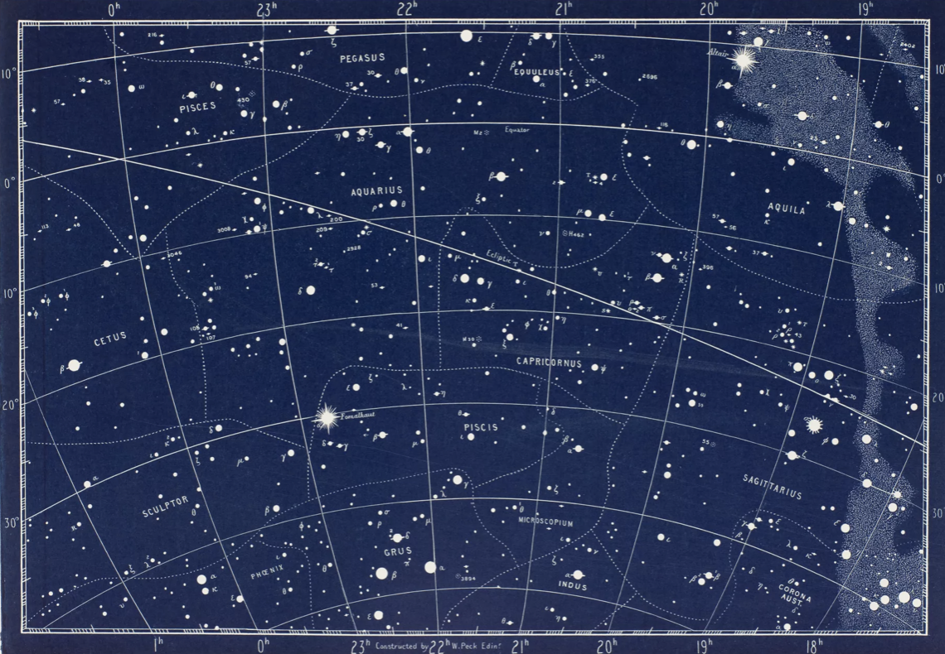

Figure 16: Star Chart depicting the position and brightness of stars in a particular region of the night sky, as viewed from a specific location and time. The chart includes constellations and other celestial bodies for reference.

### 2.3 Automatic searching and tracking of the sky objects

Automatic searching and tracking of celestial objects is an essential aspect of modern astronomy. With the continuous growth of astronomical data from ground-based observatories and space missions, the need for automated techniques to detect, identify, and track celestial objects has become increasingly important. In this section, we will discuss various methods and technologies used for automatic searching and tracking of sky objects, including image processing techniques, machine learning algorithms, and the integration of these methods with astronomical instruments.

2.3.1 Image Processing Techniques for Object Detection

Image processing techniques play a crucial role in the automatic detection of celestial objects in sky images. Some common methods employed in this context include:

* **Background Subtraction**: This technique distinguishes celestial objects from the sky by subtracting an estimated background from the original image. It effectively enhances the contrast between the objects of interest and the sky, aiding subsequent image analysis steps[7].
* **Thresholding**: A method that identifies potential celestial objects based on their brightness. By setting a brightness threshold, anything exceeding this limit is marked as an object of interest, helping to filter out less significant elements in the image[8].
* **Blob Detection**: This technique isolates groups of connected pixels that share similar attributes, such as brightness or color. These 'blobs' often correspond to celestial objects, offering a useful way to identify and categorize potential points of interest in the sky image[9].

2.3.2 Machine Learning for Object Identification and Tracking

Machine learning algorithms can be employed to enhance the accuracy and efficiency of automatic searching and tracking of celestial objects. Some common approaches include:

* Supervised learning: By training machine learning models on labeled datasets of celestial objects, these models can be used to identify and classify objects in new images.
* Unsupervised learning: Clustering algorithms can be used to group similar objects based on their features, aiding in the identification of different types of celestial objects without the need for labeled data.

2.3.3 Integration with Astronomical Instruments

Automatic searching and tracking of sky objects can be further enhanced by integrating these techniques with astronomical instruments, such as telescopes and cameras. Some possible integrations include:

* Real-time object detection: By implementing image processing and machine learning algorithms in the data acquisition process, celestial objects can be detected and tracked in real-time, allowing astronomers to respond quickly to transient events.
* Automated telescope control: By combining object detection and tracking algorithms with telescope control systems, telescopes can be automatically pointed and guided to track celestial objects of interest.
* Data fusion: By integrating data from multiple instruments or sensors, such as optical and radio telescopes, the accuracy and robustness of object detection and tracking can be improved.

The automatic searching and tracking of sky objects is an important area of research in astronomy. By leveraging image processing techniques, machine learning algorithms, and the integration of these methods with astronomical instruments, astronomers can efficiently and accurately detect, identify, and track celestial objects, ultimately enhancing our understanding of the universe[10].

## 

## 

## 

## 

## 

## 

## **3. Materials and Methods**

## 3.1 Datasets

We will utilize a comprehensive dataset of sky images, sourced from several astronomical observatories. The dataset comprises high-resolution images featuring diverse celestial objects, including planets and stars. The images have undergone standard preprocessing to ensure optimal clarity and contrast.

 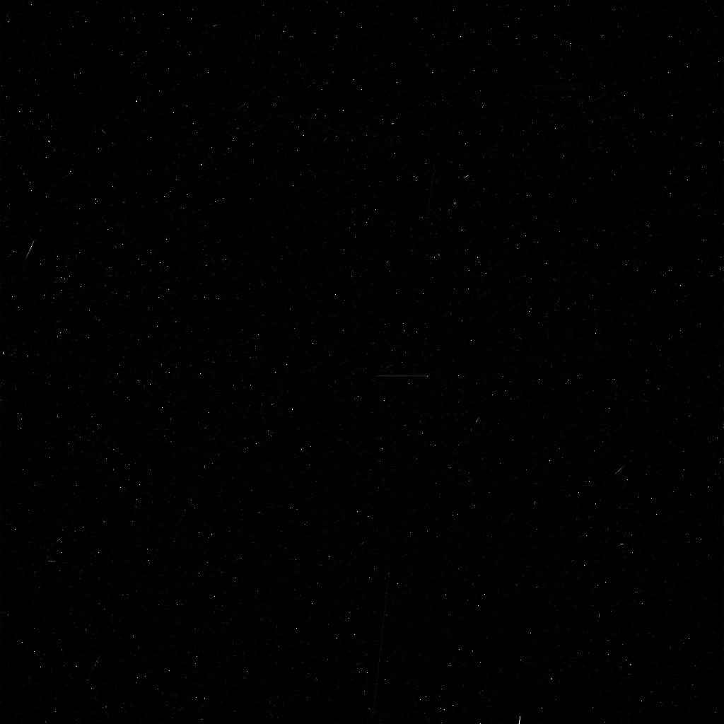

 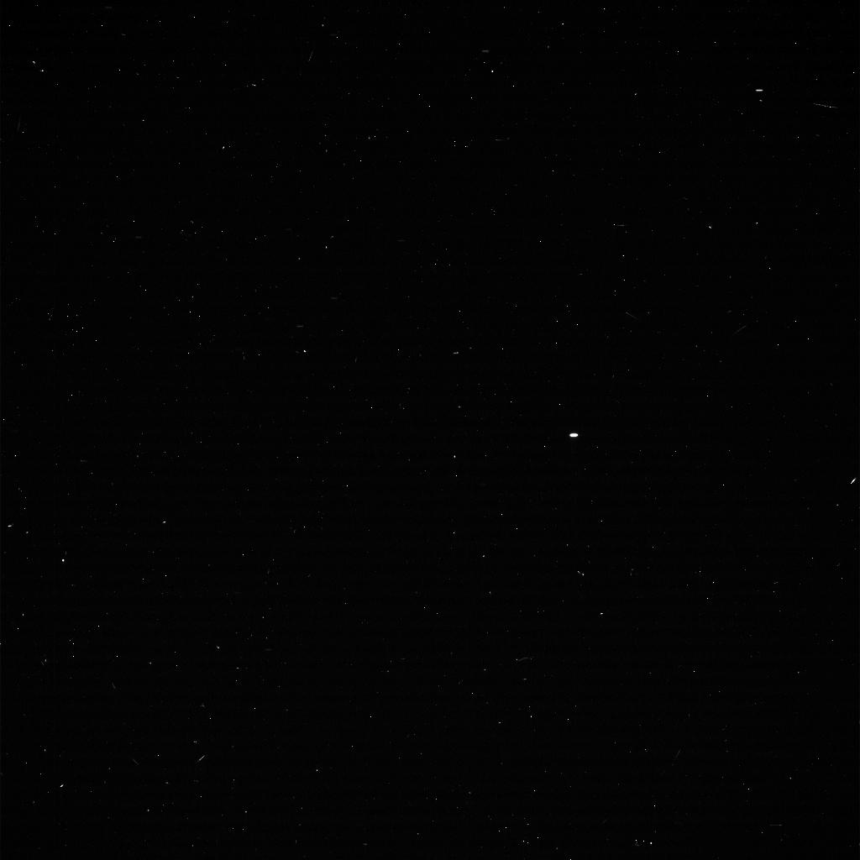

Figure 17: Database images

## 3.2 Hardware and Software

Our research will employ advanced computational resources, including high-performance computers for processing and analyzing sky images. On the software front, we will be using Python programming language equipped with image processing libraries such as OpenCV and machine learning libraries including scikit-learn and TensorFlow. For simulating celestial motions, we will utilize specialized astronomical software.

## **4. Goals and expected achievements**

## 4.1 Goals

1. Develop a comprehensive model for simulating the movement of celestial objects based on their known parameters (size, mass, distance, velocity, periodicity).

2. Apply image processing and machine learning techniques to enable automatic searching and tracking of celestial objects in both simulated and real observed sky images.

3. Estimate celestial object parameters based on observed tracks and compare them with simulated values to evaluate the accuracy of our model and techniques.

4. Validate the effectiveness and applicability of our model and techniques on real observed sky images, thereby contributing to the advancement of astronomical research.

## 4.2 Expected achievements from this research

1. A versatile and accurate celestial object movement model that can simulate sky views based on known parameters of celestial objects, providing a solid foundation for further analysis and research.

2. Efficient and reliable automatic searching and tracking techniques for celestial objects, leveraging advanced image processing and machine learning algorithms. These techniques are expected to enhance our ability to detect and track celestial objects in sky images, ultimately improving our understanding of their movements and interactions.

3. Improved methods for estimating celestial object parameters from observed tracks, providing valuable insights into the properties of these objects and contributing to the body of knowledge in astronomy.

4. Validation of our model and techniques on real observed sky images, demonstrating the practical applicability of our research in real-world astronomical studies and observations.

By achieving these goals, our research will not only contribute to the advancement of scientific knowledge in astronomy but also provide a valuable toolset for future studies and observations. Furthermore, the successful implementation of our model and techniques has the potential to facilitate new discoveries and insights into the complex movements and interactions of celestial objects, ultimately enhancing our understanding of the universe.

## **5. Process**

The research process for this project encompassed several stages, each requiring meticulous attention and strategic planning. From the initial research phase to the development and testing of our software, the project has been a continuous cycle of learning, application, and refinement.

## 5.1 Preliminary Research

Before embarking on the actual development phase, we conducted thorough background research on relevant scientific theories, image processing techniques, and coding languages. We studied astronomy's fundamental principles, especially the physical models and coordinate systems. Learning about these complex theories allowed us to lay a solid foundation for our software.

We also learned about several image processing methods and machine learning ideas, which were essential for finding celestial objects in our raw sky images. We were able to successfully create algorithms that could precisely link observed data with model predictions by understanding these strategies.

In addition to the scientific research, we also needed to understand the coding languages best suited for our project. We explored Python and its various libraries, like NumPy, Matplotlib, and TensorFlow, for their extensive capabilities in handling large datasets, performing mathematical computations, and developing machine learning models.

## 5.2 Data Collection

The collection and curation of sky images played a critical role in our project. We gathered a diverse set of images, ensuring they were of high quality and adequately represented the celestial bodies we aimed to study. We faced several challenges in this process, including dealing with vast amounts of data and ensuring the images' quality. Nevertheless, we were able to curate a useful dataset for our study.

## 5.3 Algorithm Development and Refinement

The development of key algorithms for detecting and locating celestial objects is projected to be a complex and iterative process.Our approach will be to start simple, plan everything meticulously, and gradually refine our algorithms based on the results obtained from each iteration. We anticipate challenges, including handling the inherent noise in image data and accounting for the influence of Earth's atmosphere on sky images. However, we plan to tackle these issues through a combination of image processing techniques and machine learning algorithms, continuously refining our approach based on the outcomes of our iterative testing. This iterative process will not only contribute to the functionality and accuracy of our software, but also enhance our understanding of the correlation between image-based observations and celestial mechanics.

## 5.4 Collaboration and Teamwork

Our team worked collaboratively, with tasks appropriately divided to ensure efficient progress. We regularly held meetings to update each other on our progress, discuss any challenges faced, and brainstorm solutions together. This collaborative approach allowed us to work effectively as a team and collectively overcome any obstacles encountered.

## 5.5 Future Plans

Our software, in its current state, successfully detects, locates, and correlates the movement of the major visible celestial bodies with their predicted paths based on Newton's classical mechanics and gravity model. Despite this significant achievement, we perceive immense potential for future enhancements. This includes refining our current algorithms for better accuracy, expanding our scope to less visible or even invisible celestial objects like distant stars, galaxies or obscured planets, and improving the user interface for a more intuitive user experience. We also aspire to develop real-time tracking capabilities, and to implement sophisticated techniques for mitigating atmospheric interference. Indeed, a key future goal is leveraging our project's methods to contribute to the detection of previously unseen celestial objects. We are committed to continuous improvement, using the experiences gained from this project as a stepping stone towards more advanced explorations in the realm of celestial object tracking and discovery.

## 5.6 Pseudocode

1. Initialize celestial object parameters (size, mass, distance, velocity, periodicity)

2. Load real observed sky images

3. Load training data for machine learning models

FUNCTION build_model:

1. Implement celestial motion equations based on object parameters

2. Simulate sky view according to the model

3. RETURN simulated sky view

FUNCTION automatic_tracking:

1. Implement image processing techniques for object detection

2. Train and apply machine learning models for object identification and tracking

3. RETURN detected and tracked objects

FUNCTION estimate_parameters:

1. Analyze observed tracks to estimate celestial object parameters

2. RETURN estimated parameter values

FUNCTION compare_results:

1. Compare simulated sky view with real observed sky images

2. Compare estimated parameter values with simulated ones

3. RETURN comparison results

MAIN:

1. CALL automatic_tracking on simulated model

2. CALL automatic_tracking on real sky images

3. CALL estimate_parameters on observed tracks

4. CALL build_model

5. CALL compare_results

6. OUTPUT results

This expanded research process provides a deeper understanding of our journey, detailing each phase's intricacies and challenges, our team's collaborative efforts, and our future plans for the project.

## **6. Research plan**

## 6.1 Astrophysical Data Analysis and Interpretation

In this section, we will elaborate on how the model we developed is applied to real-world data, specifically sky view images. The following steps are employed:

1. **Image Acquisition and Initial Analysis:** The sky view images are inserted into our model. For each image, various parameters are set - the location (kept constant), time, direction (defined by two angles), focal distance, and pixel size. Within each image, objects are detected, a projection to the celestial sphere is calculated, and the pairwise angles between the detected objects are determined.
2. **Object Consistency Check:** Across the set of images, we search for sets of objects that maintain similar pairwise distances, implying consistent presence in different images.
3. **Common Object Detection:** Using the information from the previous step, we detect common objects across the various images.
4. **Dynamics Calculation:** For these common objects, their dynamics on the celestial sphere are calculated.
5. **Object Classification:** We classify visible objects based on characteristics. These include the Sun (characterized by its large angular size and high luminosity), the Moon (noted for its large angular size), and others. Additionally, objects with circular trajectories, which typically correspond to stars, are identified.
6. **Center Detection:** For objects identified as stars, we detect the center of their circular trajectories.
7. **Geographical Estimation:** Based on the center of circular trajectories and the time the images were captured, we estimate the latitude, longitude, and direction.
8. **Temporal Estimation:** We estimate day, month, and year periods.
9. **Mass-Distance Relation Calculation:** Mass-distance relations for the Earth, Sun, and Moon are calculated based on the estimated periods.
10. **Earth Radius Calculation:** We calculate Earth's radius (R) based on the length of the equator.
11. **Earth Mass Estimation:** Earth's mass is estimated using the gravitational constant (G), Earth's radius (R), and the acceleration due to gravity (g=GM/R²=9.8).
12. **Sun Mass Estimation:** The mass of the Sun, as well as the distance from the Sun to the Earth, is estimated by minimizing the difference between our model's mass-distance relations and the simulation. This optimization involves adjusting a single parameter.
13. **Non-Stellar Object Analysis:** For each non-stellar celestial object, such as planets, we estimate their orbital period (T) based on stars, calculate their mass-distance relation, and estimate their distance to the Sun using the calculated relation and the estimated mass of the Sun.
14. **Planetary and Lunar Analysis:** For each planet and the Moon, we estimate their initial speed, involving three parameters per celestial body.
15. **Planetary Mass Estimation and Model Comparison:** The masses of planets are estimated by minimizing the difference between the observed results and our model. The accuracy of models, both with and without considering interplanetary forces, is compared.
16. **Model Improvement:** To refine our model, we hypothesize the existence of an invisible planet and add seven parameters to the model. This step helps us understand how the movements of known objects might be influenced by unseen celestial bodies.

## 6.2 Validation Plan

To ensure the accuracy of our celestial model, we must validate it against real-world data. This involves setting parameters, running simulations, and comparing results. Below are the steps for this process:

1. Set/load parameters of the objects: masses, initial positions, and velocities.
2. Solve the system of equations to simulate the movements of these objects.
3. For each of the selected time moments, calculate angles to objects from the observer's point of view.
4. For each of the selected directions, simulate sky view images with the selected camera parameters.
5. Compare the simulated sky view images with real-world observations or theoretical predictions to validate the accuracy and reliability of the model.

## 6.3 Diagrams

## 6.3.1 Use Case

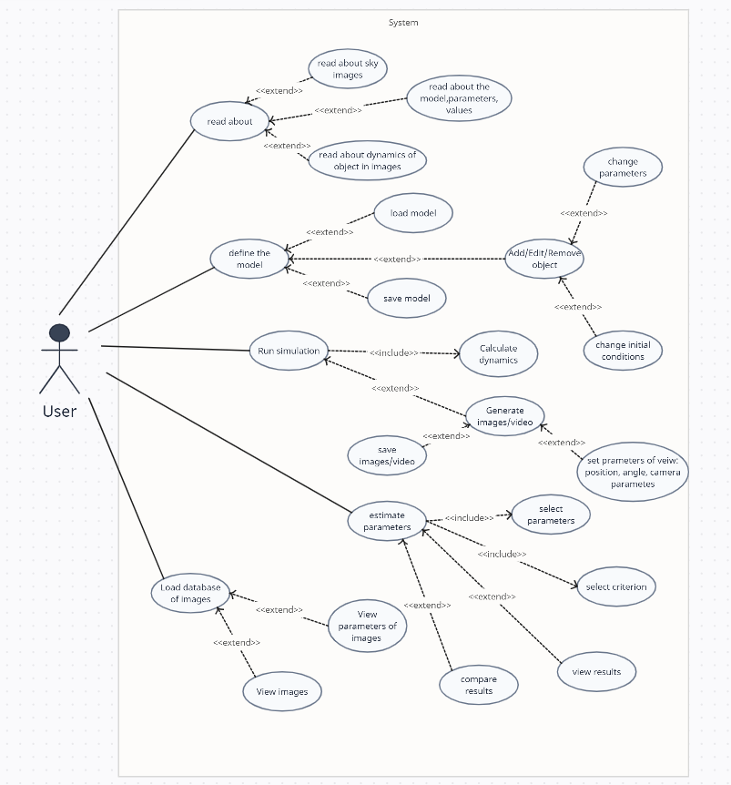

Figure 18: Activity Diagram

## 6.3.2 Activity Diagram

In direction 1,we build a dynamic celestial model using known parameters and simulate sky view images to represent our universe.

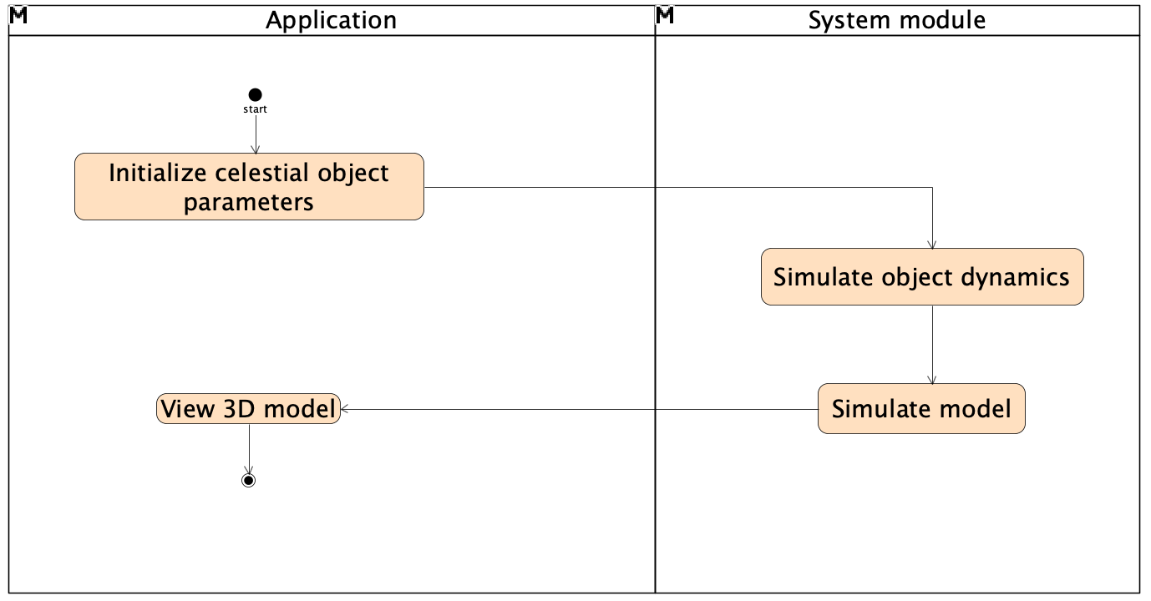

Figure 19: Direction one activity diagram

In direction 2, we utilize real-world sky images to estimate celestial object parameters, refining our model based on these observations.

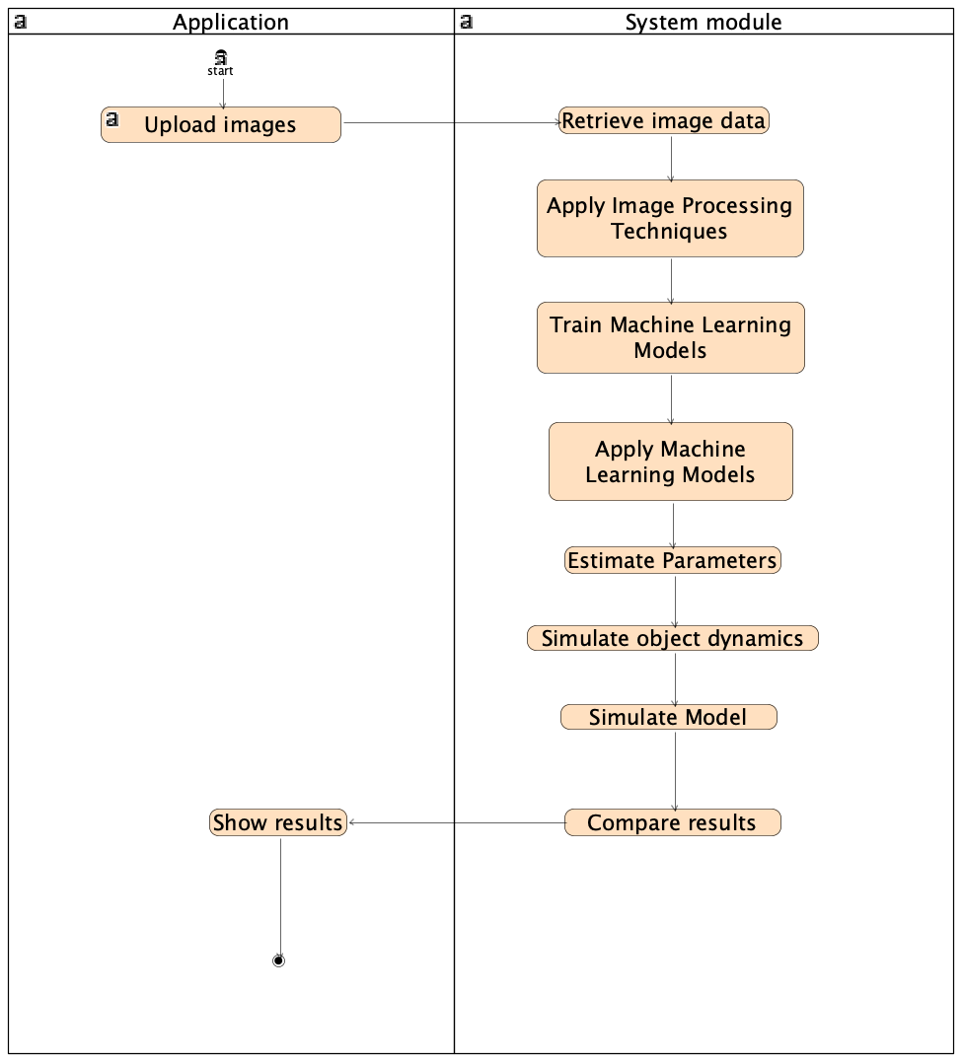

Figure 20: Direction two activity diagram

## 6.3.3 Class Diagram

The class diagram represents the system's object-oriented structure. It depicts the classes within the system, the attributes and methods within these classes, and the relationships and interactions between them.

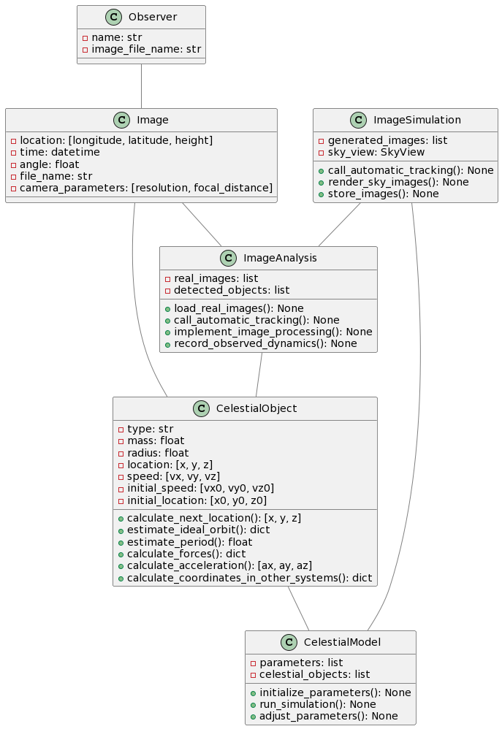

Figure 21: Class Diagram

## 6.3.4 Draft of Gui

* 1. **Object Management Page (Model Definition):** This is the entry point to our application. Here, users can add, edit, or remove celestial objects from the system. It's equipped with an interactive table for easy manipulation of object parameters. The parameters change according to the type object selected, the sun has only mass and size, stars has directions only and the parameters of the earth moon planets are mass radius, initial position and initial speed.

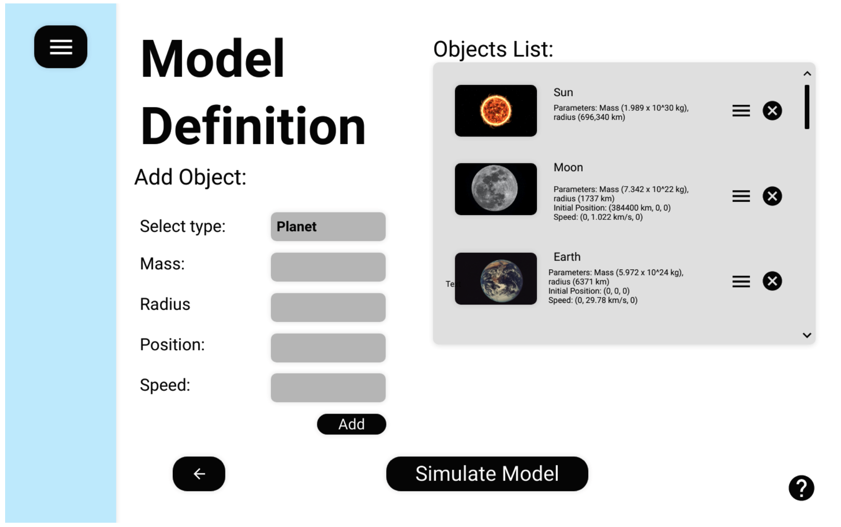

Figure 22: Model definition page where we choose the objects and their parameters for the simulation

* 2. **Simulation Run Page:** On this page, users can initiate simulations based on the defined model. They can choose to view the objects' orbits and observe their movements in a 3D environment. This dynamic visualization helps users to understand the behavior of the celestial objects over time.

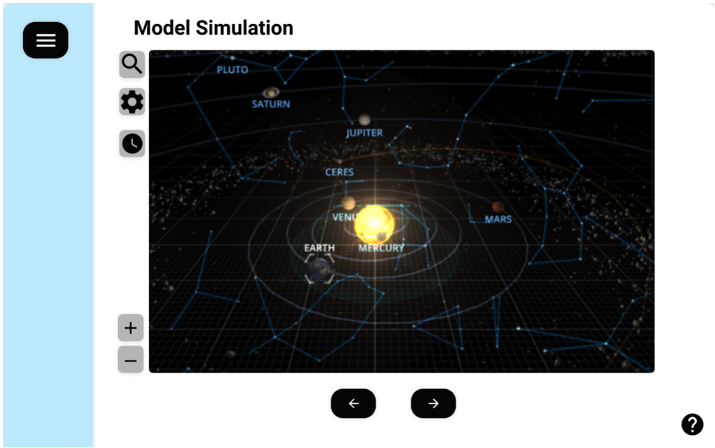

Figure 23: Model Simulation page, the page will show a simulation based on the parameters from the previous page

3. **Image Upload Page:** This dedicated page streamlines the process of importing your sky view images into the system. Users can upload multiple images at once, each of which will serve as crucial input data for parameter estimation and model validation. The user-friendly interface ensures the process is quick, intuitive, and error-free.

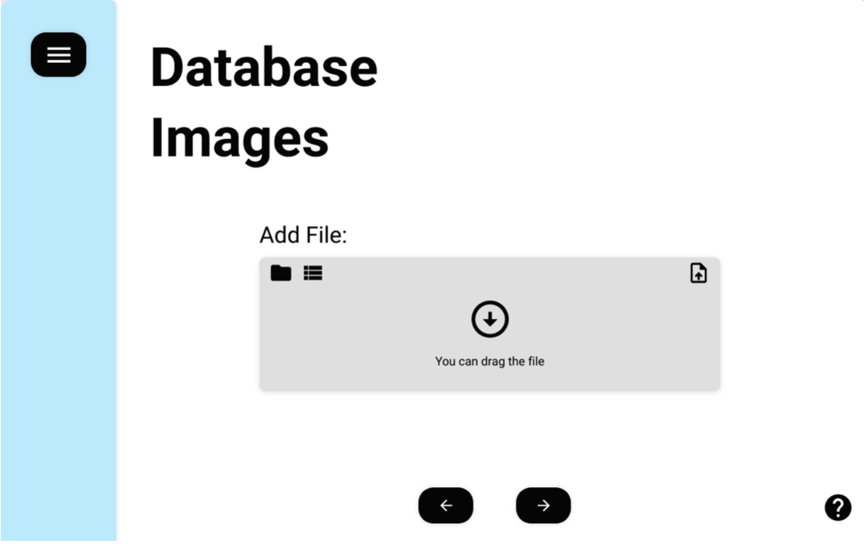

Figure 24: Database image page, where we add the images file

* 4. **Quality Control Page:** This page allows users to evaluate the performance and reliability of their model. Users can view statistical metrics comparing observed and simulated data, and visual representations of these comparisons, to make data-driven decisions for further model refinement.

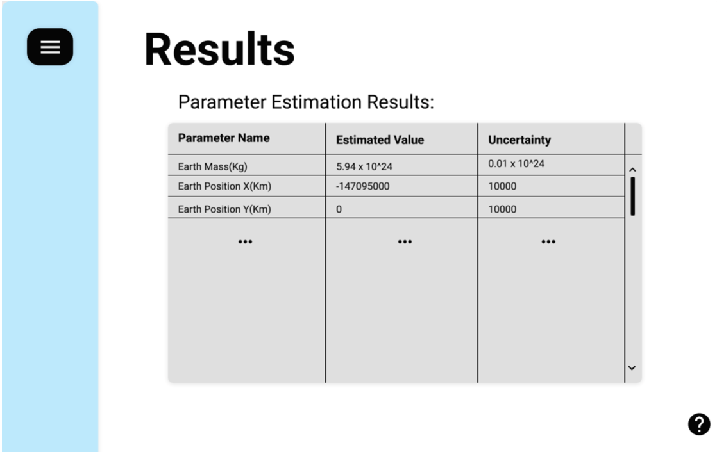

Figure 25: Results page

## 6.4 Evaluation/Verification Plan

1. **Unit Testing:** We will start with unit tests, which are designed to validate each piece of our software in isolation, ensuring that individual components function as expected.

* **Object Detection:** We will feed the software a variety of synthetic and real-world images with known objects. The software should be able to correctly identify and classify each object, such as the sun, the moon, visible planets, and stars. We will also test its performance in challenging conditions, such as images with high levels of noise, low contrast, or poor lighting conditions.
* **Motion Simulation:** We will run the software with a variety of input parameters, including masses, initial positions, and velocities, to simulate the motion of celestial objects. The outputs will be checked against theoretical predictions and known solutions to ensure accuracy.
* **Parameter Estimation:** We will validate the software's ability to estimate the parameters of celestial objects by comparing its outputs to known values.

**2. Integration Testing:** After validating the individual components, we will move on to integration testing. This step involves verifying that different components of our software work together as expected.

* **Sky View Simulation:** After simulating the motion of celestial objects, the software should be able to generate accurate sky view images based on the simulation data. We will compare these images with the expected results.
* **Tracking and Parameter Estimation:** After detecting and tracking objects in an image, the software should be able to accurately estimate the objects' parameters. We will compare these estimations with known values.

**3. System Testing:** Finally, we will conduct system testing to validate the software as a whole. This involves feeding the software a series of sky images and checking whether it can accurately detect objects, track their motion, simulate their movement, and estimate their parameters.

* **Comparison of Model with Observations:** The software should be able to compare the simulated sky view with real observed sky images and provide a quantitative measure of their agreement. We will run this comparison for a variety of scenarios to ensure that the software performs well under different conditions.
* **End-to-End Testing:** We will feed the software a series of real-world sky images, and verify whether it can accurately process these images, detect and track celestial objects, and provide accurate estimations for their parameters.

By systematically testing each component of our software and its performance as a whole, we aim to ensure its robustness and reliability. This detailed testing plan will also provide valuable feedback that can guide further improvements to the software.

## **References**

[1] Wikipedia Contributors. (2019, February 12). Kepler’s laws of planetary motion. Wikipedia; Wikimedia Foundation. <https://en.wikipedia.org/wiki/Kepler%27s_laws_of_planetary_motion>

[2]Bhuyan, S. (2022, April 27). Kepler’s First Law: Statement, Model, and Equation. Science Facts.

<https://www.sciencefacts.net/keplers-first-law.html>

[3] Absolute magnitude. (2020, February 21). Wikipedia. <https://en.wikipedia.org/wiki/Absolute_magnitude>

[4] "Atmospheric Effects," in Australia Telescope National Facility.(2020, September 16) <https://www.atnf.csiro.au/outreach/education/senior/astrophysics/atmosphere.html>

[5]Adaptive optics. (2021, March 9). Wikipedia. <https://en.wikipedia.org/wiki/Adaptive_optics>

[6] How to Calculate Arcsec. (n.d.). Sciencing. [https://sciencing.com/calculate-arcsec-515282.htm](https://sciencing.com/calculate-arcsec-5152812.html)l

[7]OpenCV: How to Use Background Subtraction Methods. (n.d.). Docs.opencv.org. <https://docs.opencv.org/4.x/d1/dc5/tutorial_background_subtraction.html>

[8]OpenCV. (n.d.). OpenCV: Image Thresholding. Docs.opencv.org. <https://docs.opencv.org/4.x/d7/d4d/tutorial_py_thresholding.html>

[9]Blob detection. (2021, April 20). Wikipedia. <https://en.wikipedia.org/wiki/Blob_detection>

[10]NASA. (2022, February 3). NASA State-of-the-Art Asteroid Tracking System Now Capable of Full Sky Search. SciTechDaily. <https://scitechdaily.com/nasa-state-of-the-art-asteroid-tracking-system-now-capable-of-full-sky-search/?expand_article=1>

[11]The Physics Classroom. (2019). *Newton’s Law of Universal Gravitation*. Physicsclassroom.com. <https://www.physicsclassroom.com/class/circles/Lesson-3/Newton-s-Law-of-Universal-Gravitation>

[12]Coordinate Transformation Coordinate Transformations. (n.d.). Retrieved June 25, 2023, from

<https://math.etsu.edu/multicalc/prealpha/chap3/chap3-1/printversion.pdf>

[13]‌Weisstein, E. W. (n.d.). *Spherical Coordinates*. Mathworld.wolfram.com. <https://mathworld.wolfram.com/SphericalCoordinates.html>

[14]Celestial Coordinate System. (n.d.). Www.pas.rochester.edu. Retrieved September 19,2022,from

<https://www.pas.rochester.edu/~blackman/ast104/coordinates.html>

[15]Equatorial Coordinate System | COSMOS. (n.d.). Astronomy.swin.edu.au. Retrieved December 16, 2020, from <https://astronomy.swin.edu.au/cosmos/e/equatorial+coordinate+system>

[16]Bikos, K. (2019). The Horizontal Coordinate System. Timeanddate.com. <https://www.timeanddate.com/astronomy/horizontal-coordinate-system.html>

[17]Mahajan, S. (2020). A Student’s Guide to Newton’s Laws of Motion. In Google Books. Cambridge University Press. <https://books.google.co.il/books?id=jHzUDwAAQBAJ&printsec=copyright&redir_esc=y#v=onepage&q&f=false>

[18]Ecliptic coordinate system. (2023, January 21). Wikipedia. <https://en.wikipedia.org/wiki/Ecliptic_coordinate_system>

‌